
NORTHERN EDUCATION DIVISION
NORTHERN EDUCATION DIVISION MOCK EXAMINATION
2026 MALAWI SCHOOL CERTIFICATE OF EDUCATION EXAMINATIION

BIOLOGY
PAPER 1
Theory
100 marks

Wednesday, 18th March Subject Number: M022/I
Time allowed: 2hours
8:00 am – 10:00 am
Instructions:
Question Number | Tick if answered | Do not write in these columns
1
2
3
4
5
6
7
8
9
10
11
12
13
Total
1. This paper contains printed 13 pages. Please check.
2. This paper contains sections A and B Answer all questions in all sections.
3. Write your answers on the question paper provided. The maximum number of marks for each question is indicated against each question.
4. Answer all the 13 questions in the spaces provided.

SECTION A (70 MARKS)
- a. Mention any two significances of osmosis.
____________________________________________________________________________________________________________________________ (2mark)
b. Explain one way of mitigating the impact of climate change.
______________________________________________________________________________________________________________________________________________________________________________________________(2marks)
c. Explain how the Fossils records support the theory of evolution.
__________________________________________________________________ __________________________________________________________________ ________________________________________________________ ( 2Marks )
- a. Define tropisms?
____________________________________________________________________________________________________________________________ (1mark)
b. Explain one importance of phototropism
___________________________________________________________________________________________________________________________ (2 marks)
c. State any two principles of Mendelian genetics
___________________________________________________________________________________________________________________________(2 marks)
d. Explain any one adaptation of the alveolus to its function.
____________________________________________________________________________________________________________________________(2 marks)
- a. Distinguish between fertilization and conception.
_______________________________________________________________________________________________________________________________________________________________________________________________(1mark)
b. Figure 1 is a diagram showing a certain movement in fish.
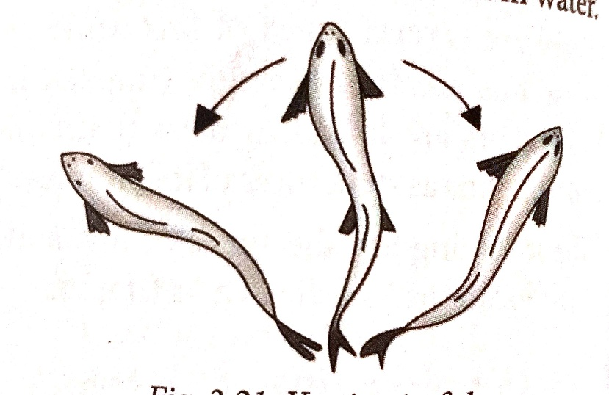
Figure 1
- Identify the movement shown by fish in figure 1.
______________________________________________(1 mark)
- Mention two fins that the fish use to prevent the fish movement in figure 2
__________________________________________________________________________________________________________________(2marks)

c. Explain how red blood cells transport oxygen
____________________________________________________________
_____________________________________________________ (2 Marks)
d. Describe any one abnormal condition of the nervous system.
__________________________________________________________________ _________________________________________________________ (2 Marks)
- a. Figure 2 is a diagram, showing two types of respiration in the form of equation P and Q
P: glucose+oxygen→carbondioxide+water+2898kj energy
Q: glucose→ lactic acid+150KJ of energy
- write down a balanced chemical equation for equation P

(3marks)
- In which part of a cell does equation Q takes place
_________________________________________________(1mark)
- Explain the difference in amount of energy produced between equation P and Q
______________________________________________________________________________________________________________________________________________________________________________ (3Marks)
- a.Mention the structure that is responsible for the production of follicle stimulating hormone in the body.
______________________________________________________(1Mark)
b. Explain one way in which mitosis cause growth in organism.
____________________________________________________________________________________________________________________________(2 mark)
c. Explain one effect of water intake on urine production
___________________________________________________________________________________________________________________(2marks)
d. Explain why the patients’ blood and the dialysis fluid move to opposite directions in the dialysis.
___________________________________________________________________________________________________________________________ (2 Marks )
e. Give three adaptations of the nephron to its function.
_____________________________________________________________________________________________________________________________________________________________________________________________ (3marks)
- a. Haemophilia is a sex-linked trait. A man who is haemophilic is married to a woman who is heterozygous for this trait. Using an allele H for normal clotting of blood and allele h for haemophilia.

- Draw a genetic cross to show the possibility of giving birth to children who are haemophilic

(4marks)
- If a family has eight children, calculate the number of children who will be carriers of haemophilia. Show your working

(2marks)

- Figure 3 is a diagram of a plant cell as seen through a light microscope.
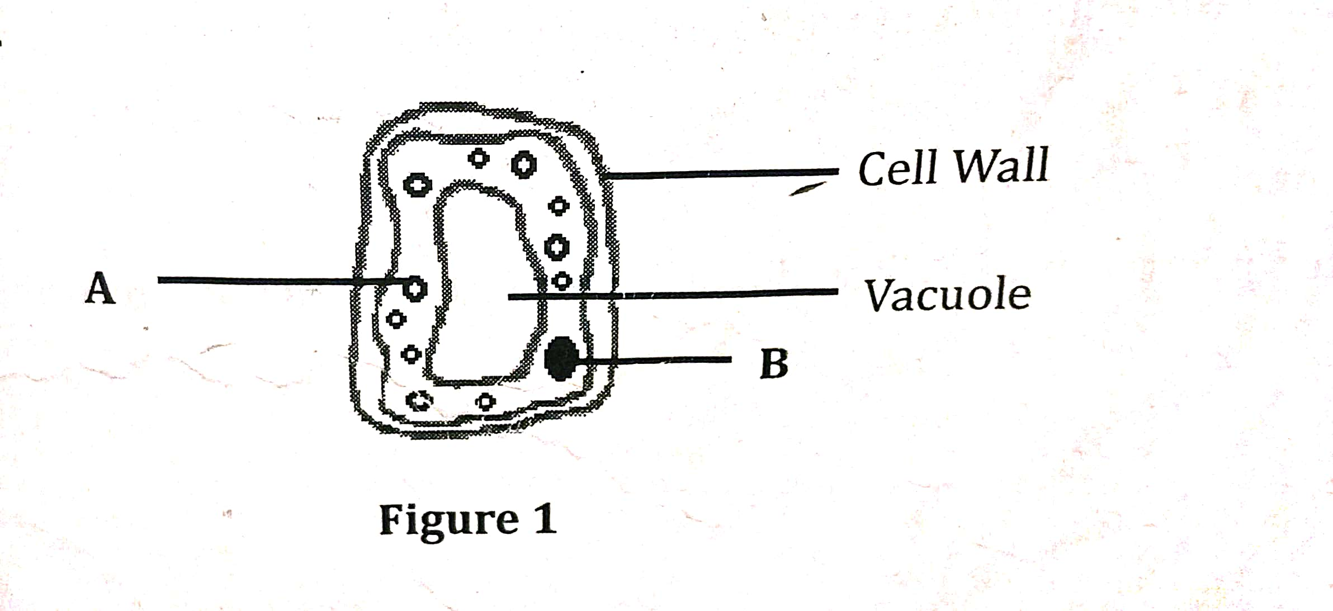
Figure 4
- Name the part labelled B __________________________________________________ (1 mark)
- What name is given to the cell in figure 3
____________________________________________________( 1 Mark)
- Explain one adaptation of the cell in figure 3 to its function
_______________________________________________________________________________________________________________ (2 marks)
- Explain any one factor that affect the rate of diffusion.
______________________________________________________________________________________________________________________( 2 Marks)

- a. Figure 4 is a diagram of longitudinal section of phloem tissue
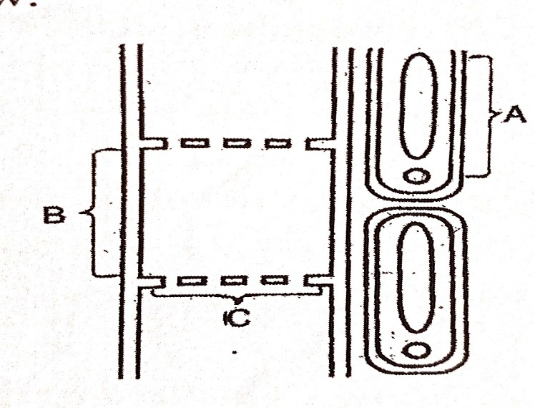
Figure 4
- Name the parts marked B and C
B. _________________________________________________(1 mark)
C. _________________________________________________(1 mark)
- Complete the table below to show the two structural differences between xylem and phloem.
Xylem | Phloem
(2marks)
- State any one function of the part marked A
___________________________________________________________(1 mark)
b. Name any one cell that makes xylem tissue
__________________________________________________________ (1 Mark)
- a. Define “passive immunity”.
_____________________________________________________________________________________________________________________________(1markb. Explain how each of the following helps the body to defend itself against infection.
- Platelets ____________________________________________________________________________________________________________________________(2marks)
- Stomach_____________________________________________________________________________________________________________________(2marks)
c. Mention any one examples of discontinuous variation. ___________________________________________________________________________________________________________________________ (2 Marks)
- a. State any two examples of simple reflex.
___________________________________________________________________________________________________________________________ (2 Marks)
b. State any two diseases which are caused by fungi in human beings.
___________________________________________________________________________________________________________________________ (2 Marks)

c. Figure 5 is a diagram showing an experimental set up which is left to stand for some hours.
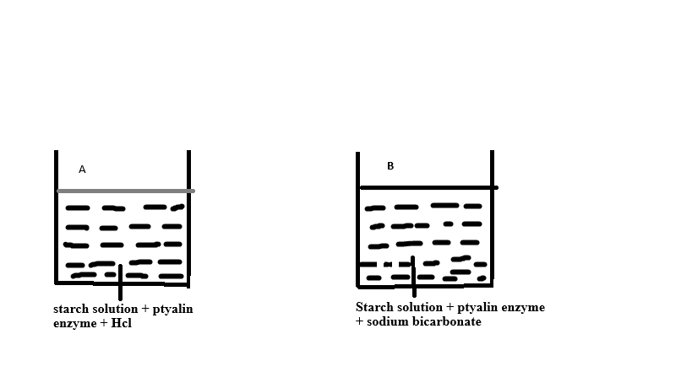
Figure 5
- State the property of enzyme being investigated in figure 5
_____________________________________________________ (1 Mark)
- Which set up provides better condition for the work of ptyalin?
____________________________________________________ (1 Mark)
- Describe the result in set up A when iodine solution is added.
_____________________________________________________________________________________________________________________________________________________________________________________ (2 Mark)

SECTION B (30MARKS)
Answer all the three questions in this section. All your answer should be in an essay form.
- Describe how urine is formed
_________________________________________________________________________________________________________________________________________________________________________________________________________________________________________________________________________________________________________________________________________________________________________________________________________________________________________________________________________________________________________________________________________________________________________________________________________________________________________________________________________________________________________________________________________________________________________________________________________________________________________________________________________________________________________________________________________________________________________________________________________________________________________________________________________________________________(10marks)

- Describe any five adaptations of leaves to photosynthesis.
________________________________________________________________________________________________________________________________________________________________________________________________________________________________________________________________________________________________________________________________________________________________________________________________________________________________________________________________________________________________________________________________________________________________________________________________________________________________________________________________________________________________________________________________________________________________________________________________________________________________________________________________________________________________________________________________________________________________________________________________________________________________________________________________________________________________________________________________________________________________________________________________________________________________________________________________________________________________________________________________________________________________________________________________________________________________________________________________________________________________ (10marks)
- A Form four student was coming back from school. On his way, he saw a big snake, and run away. Explain how the adrenaline hormone prepared the body for the action.
________________________________________________________________________________________________________________________________________________________________________________________________________________________________________________________________________________________________________________________________________________________________________________________________________________________________________________________________________________________________________________________________________________________________________________________________________________________________________________________________________________________________________________________________________________________________________________________________________________________________________________________________________________________________________________________________________________________________________________________________________________________________________________________________________________________________________________________________________________________________________________________________________________________________________________________________________________ (10 marks)
END OF QUESTION PAPER
NB: This paper contains 13 printed pages.

